

**STAT40720 Intro. to Data Analytics**

**Assignment 4**



**Name** Kevin O’Connell

**Student ID** ########

**Submission Date** 16ndth November 2015

**Question 1**

To complete the analysis, a plot of the average spend per hour versus time to next withdrawal was computed.

**(a) Weekend Withdrawal**

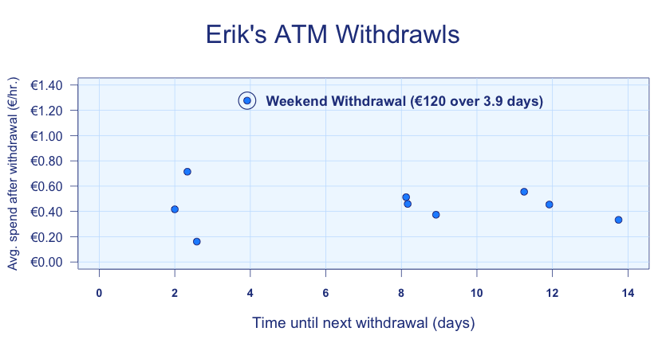

Erik’s withdrawal prior to the weekend away is likely to have the highest average spend over a period of 3 to 4 days. The most likely candidate is observation 5, where €120 was withdrawn and spent over 94 hours.

**(b) Sick Withdrawal**

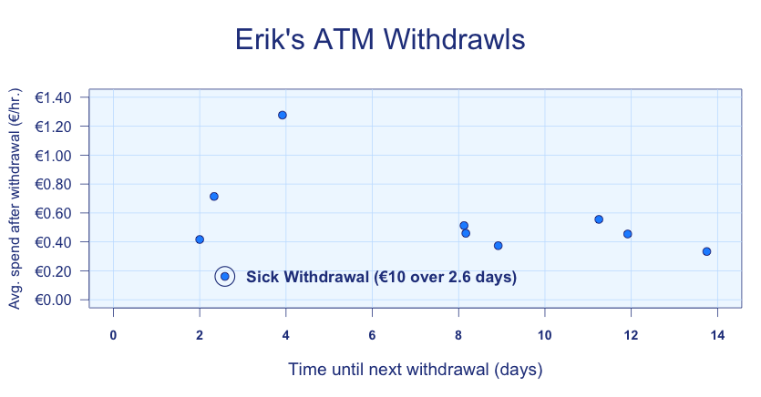

Erik’s withdrawal prior to getting sick and confined to bed is likely to have the lowest average spend over a relatively short period of 2 to 3 days. The most likely candidate is observation 2, where €10 was withdrawn and spent over 62 hours.

**Question 2**

1. **The equation of the regression line**

$b$ $=\frac{\sum{xy}-\frac{\sum{x}\sum{y}}{n}}{{\sum{x}}^{2}-\frac{{\left(\sum{x}\right)}^{2}}{n}}$

$=\frac{\sum{(x-\overline{x})(y-\overline{y})}}{{\sum{\left(x-\overline{x}\right)}}^{2}}$

$=\frac{371}{202}$

$=1.8366$

To find the value of *a*, the mean value of x and y must be found.

$\overline{x}$ $=\frac{\sum{x}}{n}=\frac{112}{7}=16$

$\overline{y}$ $=\frac{\sum{y}}{n}=\frac{224}{7}=32$

$∴a$ $=\overline{y}-1.8366\overline{x}$

$=32-1.8366(16)$

$=2.6144$

The above regression shows from the figure *b*, that for each minute after 8:08am the teacher leaves, the journey time increases by 1.84 minutes.

The value of *a* shows and extrapolation back to 8:00am from this data would yield a journey time of 2.6144 minutes. This is, of course, not practical, but it can be used to show the expected minimum journey time for an 8:08am departure is given by:

$y_{x=8}$ $=2.6144+1.8366\left(8\right)$

$=17.3$

Therefore, the expected minimum travel time is 17.3 minutes.

1. **8:15am Departure Time**

$y_{x=15}$ $=2.6144+1.8366\left(15\right)$

$=30.1634$

For an 8:15am departure, the expected journey duration is 30.2 minutes.

1. **8:15am Departure Time 95% Confidence Interval**

$\sum{y^{2}}$ $=\sum{{\left(y-\overline{y}\right)}^{2}}+\frac{{\left(\sum{y}\right)}^{2}}{n}$

$=722+\frac{{224}^{2}}{7}=7890$

$\sum{xy}$ $=\sum{\left(x-\overline{x}\right)\left(y-\overline{y}\right)}+\frac{\sum{x}\sum{y}}{n}$

$=371+\frac{112×224}{7}=3955$

${SS}_{resid}$ $=\sum{y^{2}}-a\sum{y}-b\sum{xy}$

$=7890-2.6144×224-1.8366×3955$

$=40.63$

${95\% CI}_{x=15}$ $=a+bx^{*}±t_{CRITICAL}×s_{a+bx^{*}}$

$=a+bx^{*}±t_{CRITICAL}×s_{e}\sqrt{\frac{1}{n}+\frac{{\left(x^{*}-\overline{x}\right)}^{2}}{S_{xx}}}$

$=a+bx^{*}±t_{CRITICAL}×\sqrt{\frac{{SS}_{resid}}{n-2}}\sqrt{\frac{1}{n}+\frac{{\left(x^{*}-\overline{x}\right)}^{2}}{\sum{{\left(x-\overline{x}\right)}^{2}}}}$

$=2.6144+1.8366×15±2.571×\sqrt{\frac{40.63}{5}}\sqrt{\frac{1}{7}+\frac{{\left(15-16\right)}^{2}}{202}}$

$=30.163±2.81766$

1. **Interpret (c)**

The value from (c) states that we can be 95% confident the mean population value of journey time for an 8:15am departure lies within 2.82 minutes of 30.16 minutes.

1. **95% Prediction Interval**

${95\% PI}_{x=15}$ $=a+bx^{*}±t_{CRITICAL}×\sqrt{{s_{e}}^{2}+{s_{a+bx^{*}}}^{2}}$

$=2.6144+1.8366×15±2.571×$

$\sqrt{{\left(\sqrt{\frac{40.63}{5}}\right)}^{2}+{\left(\sqrt{\frac{40.63}{5}}\sqrt{\frac{1}{7}+\frac{{\left(15-16\right)}^{2}}{202}}\right)}^{2}}$

$=30.163±2.571×3.054$

$=30.163±7.8519$

1. **8:30am Prediction Feasibility**

Although a prediction of travel time for a departure time at 8:30am is physically possible, there is no evidence or observations to suggest this model holds for this departure. Therefore, this model should not be used to perform such a prediction.

**Question 3**

Case 1 – Removing case “+” should yield r = 0.285

Case 2 – Removing case “x” should yield r = 0.720

Case 3 – Removing case “+” and “x” should yield r = 0.925